Jack Johnson

August 17, 2021

Section End Project: Portfolio Project

Link to my GitHub repository: <https://github.com/jjohn98/2058519_Jack_Johnson_Mean_Stack>

This project is located in ~/Phase2/portfolio-project.

In this project, I created a new angular project and then created 3 components. These components were for each of the respective elements of the design. There is a login component which handles the user logging in. There is also a reset button which deletes all accounts to make testing easier. The next component is the registration component, which handles users creating new accounts. The third component is the portfolio component. This displays only when a user is logged in, and can accept inputs for more contacts to be added to the user’s portfolio. There is also a log out button which will log out the currently logged in user.

Each of these components are hidden and unhidden when the respective button is clicked at the top navigation bar. Once the user is logged in, they can simply click the portfolio button at the top to be taken to their portfolio, where they can then click the load contacts button to load all of their saved contacts.

The files for this project will be in the GitHub repository, as well as the source code section of the submission on Simplilearn.

Screenshot of Web pages created:

**Login Screen:**

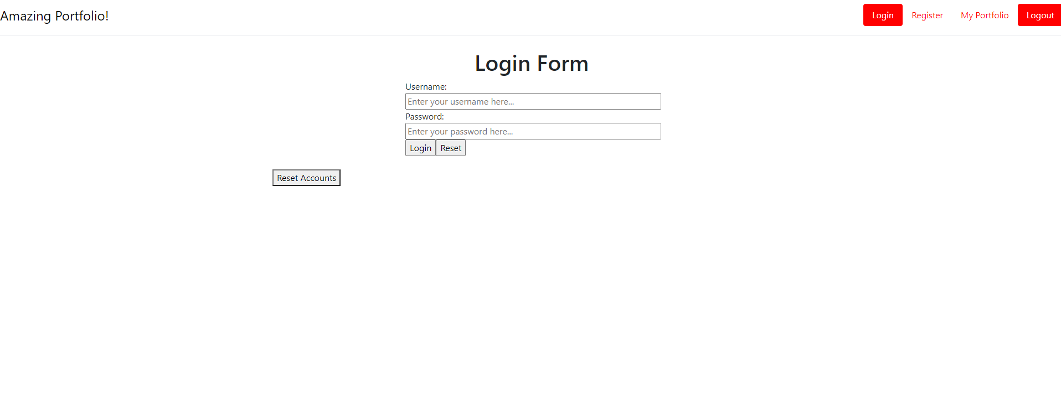

**Registration Screen:**

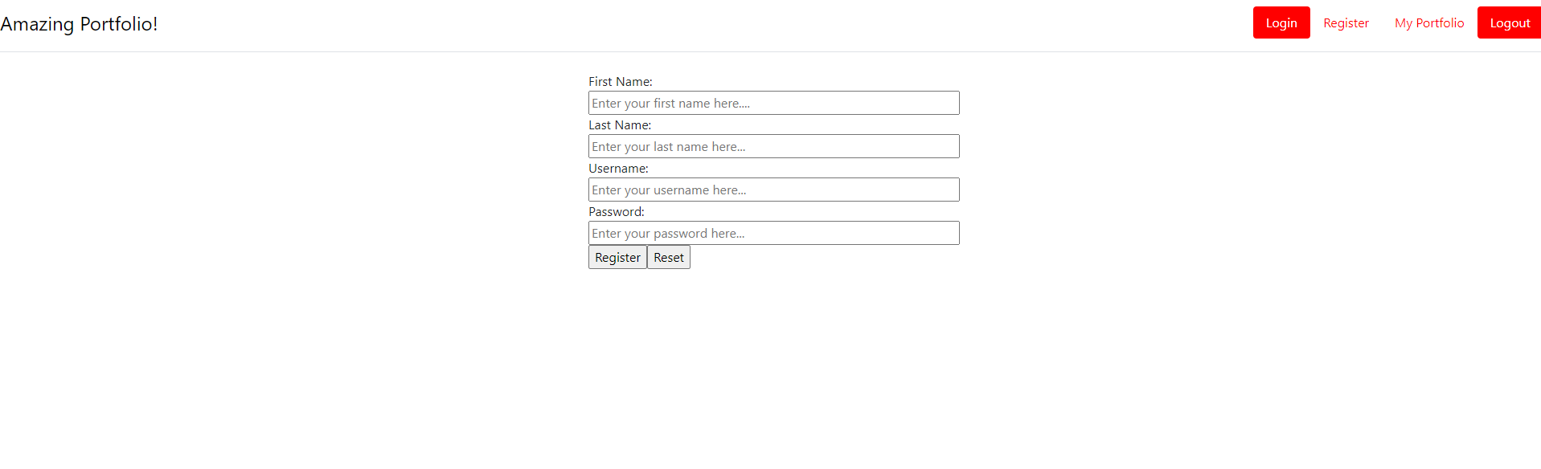

**Portfolio Screen:**

